|  |  |
| --- | --- |
| **#** | **Release Features** |
| 1 | Create PFM Version Odata |
| 2 | Create Bucket/Item Version |
| 3 | Delete Bucket/Item Version |

1. Create PFM Version Odata

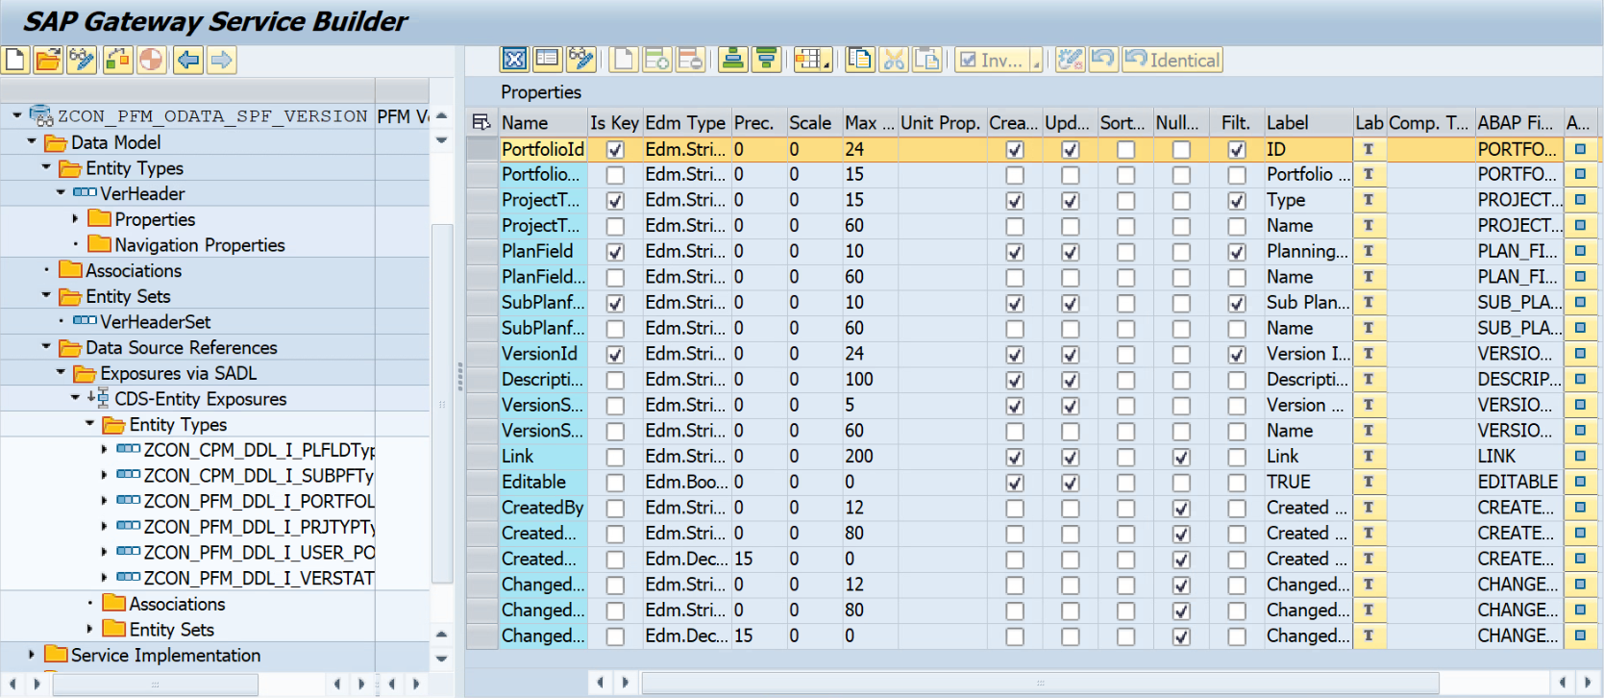

1. Create Bucket/Item Version

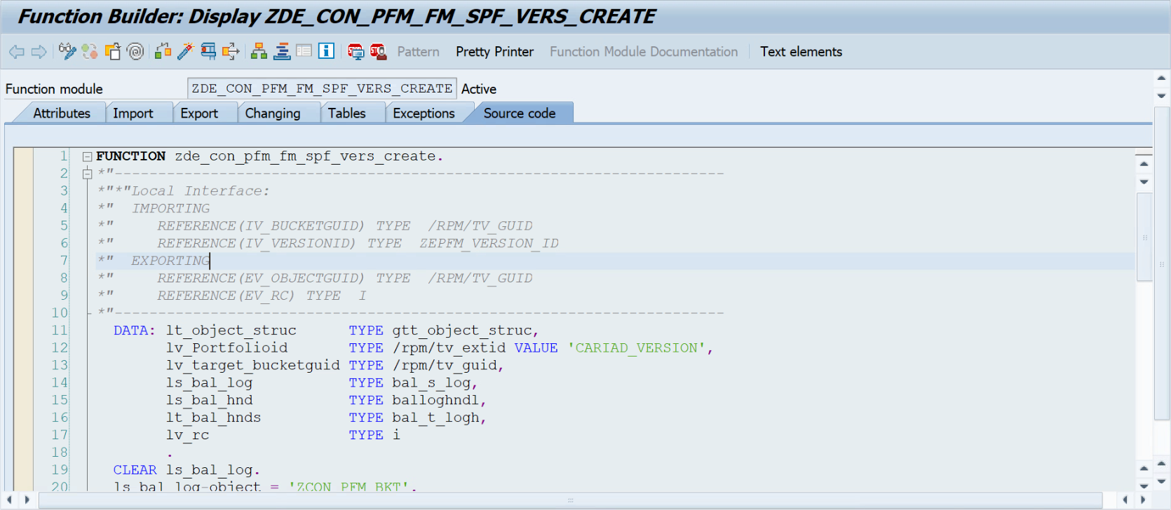

1. Delete Bucket/Item Version

